**Project Topic: Weather Prediction using RNN & Classification RF**

Download Dataset from kaggle which consist of 1 csv file name as “seattle-weather.csv”. Dataset containing a Weather conditions based on samples. Dataset have 6 attribute and 1461 instances. Following Steps are followed to predict weather.

Step1:  Classification with Random Forest

Step 2: Preparing Data for Classification¶

Step 3: Grid Search and Random Forest

Step 4: Clearing More

**Code:**

**Weather Prediction using RNN**

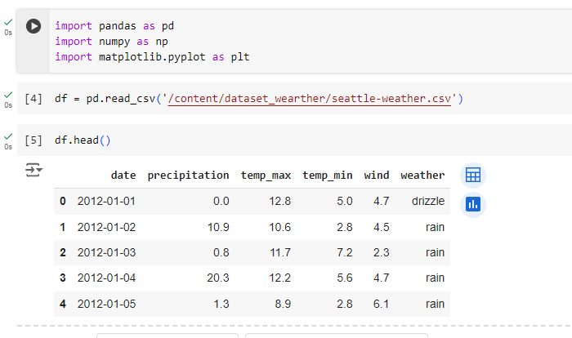

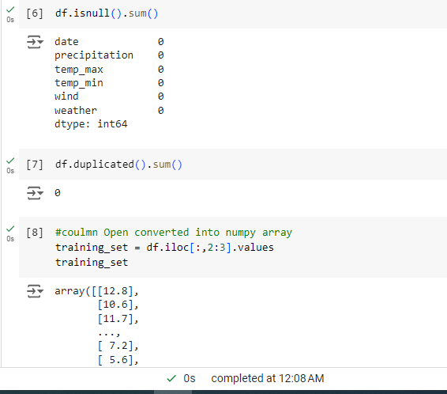

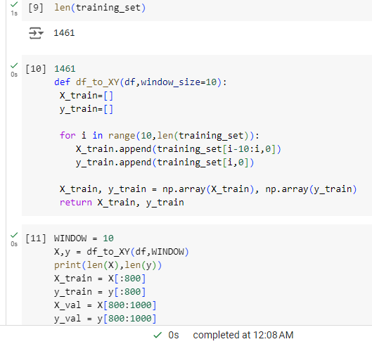

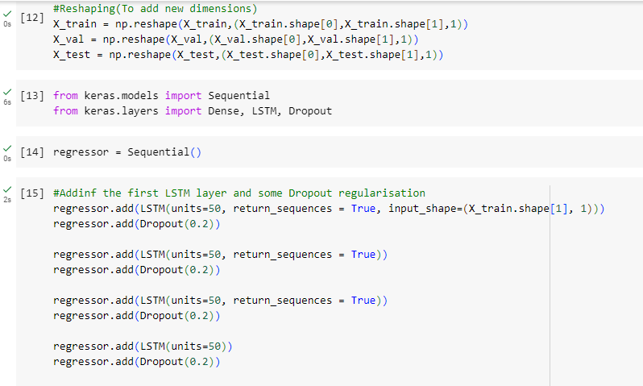

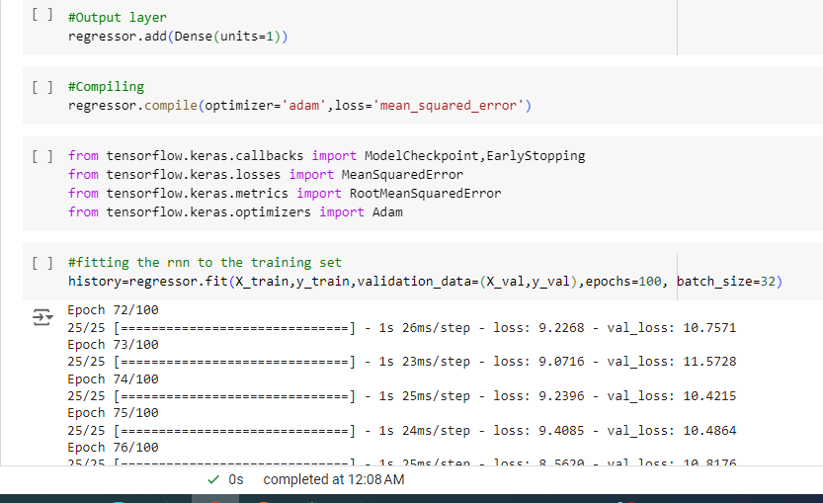

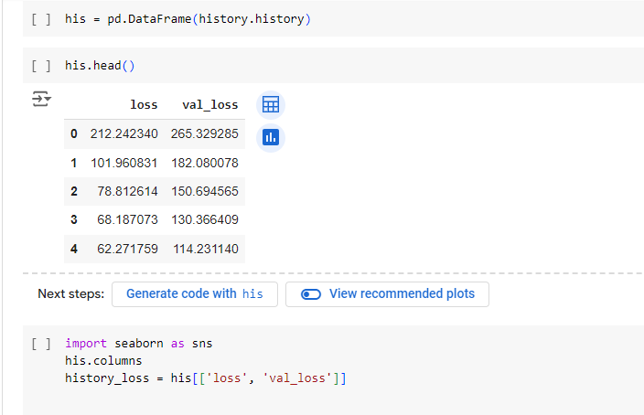

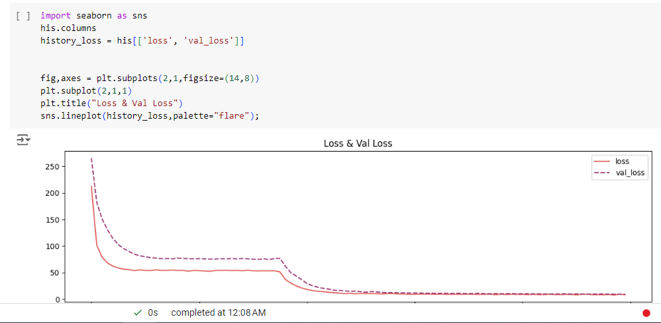

# Weather Prediction - Classification (RF)

# 

# 

# 

# 

# 

# 

# 

# 

# 

# 

# 

# 